Hadoop Introduction:-
What is Bigdata Engineering?
Bigdata:-
- It is a Huge volumes of data, it cannot be stored and processed using traditional technologies like RDBMS (Oracle, MySQL, PostgreSQL, DB2, etc..), and Application Programming’s (Java, Scala, .Net, etc..) with in short time.

Bigdata Engineering Technologies:-
- Bigdata Engineering with Python
- Bigdata Engineering with Java
- Bigdata Engineering with Scala
- AWS Bigdata Engineering
- Azure Bigdata Engineering
- GCP Bigdata Engineering (Google Cloud Platform)
- Etc..

Pre-Requisites:-
- Operating System – Linux Essentials or Linux Foundation or Linux Basics or Linux for EveryOne
- SQL – Structured Query Language ( May on MySQL or Oracle or PostgreSQL or MS SQL Server or Any RDBMS)
- Language – Python (Core Python + Advanced Python) or Java (Core Java) or Scala Programming

Common Technologies for Any Bigdata Engineering:-
- Hadoop Foundation – Hadoop Introduction, Features of Hadoop, Different Vendors of Hadoop, Hadoop Architecture, Component of Hadoop, HDFS Filesystem, Hadoop Installation.
- Hadoop Development -- HDFS Commands, MapReduce using Java or Python, Apache Pig (Currently it is very less usage), Apache Hive (It is mostly used Technology), Apache HBase Hive (It is mostly used Technology), Apache SQOOP (Currently it is very less usage), Apache Flume (Currently it is very less usage), Apache Oozie (It is mostly used Technology)
- Apache Spark – It is mostly used technology – It has complete processing –
Spark Foundation, Spark Core, Spark SQL, Spark Streaming, Spark Integration

Bigdata Engineering with Python or Java or Scala
Pre-Requisites + Common Technologies for Any Bigdata Engineering + Kafka Streaming + NoSQL Databases like Cassandra or HBase or MongoDB etc..

AWS or Azure or GCP
Pre-Requisites + Common Technologies for Any Bigdata Engineering + Every Cloud Compute has their own Streaming Frameworks like Kensis (AWS Streaming) + Every Cloud Computing has their own NoSQL Databases like Redshift (AWS NoSQL Database) + Every Cloud Compute has additional Bigdata Engineering Technologies like AWS EMR, AWS Glue, AWS Athena, AWS Lambda Functions etc..

What is Bigdata?
- Huge volumes data it cannot be stored and processed using traditional technologies like RDBMS and Application programming within short time.
- We cannot measure Bigdata
For example today we are saying 1PB Data is a Bigdata.
Facebook generating 200TB data daily
1024TB ➔ 1PB
1024TB/200TB➔ 5 or 6 days Facebook generates 1PB
- RDBMS databases does not support unlimited storage. RDBMS is not distributed system.

Classification of Bigdata:-
- Bigdata can be classified into 3 categories. They are:
- Structured Data (Hadoop, RDBMS)
- Semi-Structured Data (Hadoop, Most of RDBMS not supporting Semi-Structured)
- Un-Structured Data (Hadoop, RDBMS does not support).

Structured Data:-
- Data has proper format associated with it.
E.g:- Table
Before storing data, we will create table with column names and data types.
E.g:-
Create table emp(empno int,ename, string,sal int);
- Hadoop and RDBMS supports Structured data.

Semi-Structured Data:-
- It does not have proper format associated with it but based data we data we can identify.
E.g:- Log Files
CustomerViews.log
101 | sreenivas | 192.168.1.100 | 04:09:2021:07:53PM | browsed new courses page
101 | sreenivas | 192.168.1.100 | 04:09:2021:07:53PM | browsed new courses page
101 | sreenivas | 192.168.1.100 | 04:09:2021:07:53PM | browsed new courses page
101 | sreenivas | 192.168.1.100 | 04:09:2021:07:53PM | browsed new courses page
- Hadoop Supports Semi-Structured data but RDBMS does not supports Semi-Structured data.

Un-Structured Data:-
- Data does not have any format associated with it.
E.g:- User Reviews
User1:
Bigdata Engineering at Ananth IT is excellent and Akkem Sreenivasulu is Excellent Trainer for any Bigdata Engineering
- Hadoop Supports Un-Structured data but RDBMS does not supports Un-Structured data.

Characteristics of Bigdata:-
- There are 3V’s but some people say 5V’s or 7V’s but mainly 3V’s. They are:
- Volume
- Velocity
- Variety

Volume:-
- Huge volumes data.
- How huge your data.
- Hadoop supports unlimited storage.
- There is no limit for Hadoop Cluster
- RDBMS does not support unlimited Data.
- RDBMS has a limitation in Cluster size.

Velocity:-
- How much speed your data is growing is called Velocity.
- Facebook generating 200TB data daily.
- Twitter processing 400 Million twits .
- In YouTube each minute 48hours video is video is upload

Variety:-
- Variety means
Structured
Semi-Structured and
Un-Structured.

Challenges associated with Bigdata?
- Storage – Bigdata means – Huge volumes or Unlimited data. There is no traditional technology which supports Unlimited storage.
- Processing – If data is less traditional technologies processing very faster but if data is huge processing is slow.
- So to resolve Bigdata challenges Hadoop is introduced, it has two core components. They are:
HDFS Filesystem – It supports unlimited storage.
MapReduce – It supports parallel processing.

What is Hadoop?
- Hadoop is a Bigdata Framework.
- Hadoop Software implemented using Java Language.
- Hadoop Software implemented based on two papers published by Google called
GFS – Google Filesystem
MapReduce
Google Implemented Bigdata using Python Language.
Hadoop is Implemented by Dough Cutting, He implemented Hadoop using Java Language.
- The Vendor of Hadoop is Apache Software Foundation.
- Hadoop is a free and Opensource Framework.
Free – No Licence Cost
Opensource – They give us complete source code.
- Hadoop has two core components. They are:
HDFS – Hadoop Distributed Filesystem, It supports unlimited storage.
MapReduce – It is a Parallel processing algorithm.

Different Vendors of Hadoop:-
- Apache Hadoop Software is implemented using Java Language.
- Apache Hadoop is Free and Opensource
Free – No Licence Cost
Opensource – They give us complete source code
- Based on Apache Hadoop opensource, many vendors implemented Enterprise Versions.
CDH – Cloudera Distribution Hadoop
HDP – Hortonworks/Hadoop Data Platform
MapR Hadoop – MapR Hadoop
AWS EMR – Elastic MapReduce – AWS
IBM Big Insights – IBM Bigdata
Microsoft HD Insights – Microsoft
etc..
- Cloudera + Hortonworks merged ➔ From CDH 7 (Cloudera Distribution Platform) or CDP 7 (Cloudera Data Platform)

Hadoop Features
1. Cost Effective:-
- Hadoop is free and opensource
Free – No Licence Cost
Opensource – They give complete source code.
- Hadoop works on Commodity Hardware.
PC < Commodity Hardware < Server Hardware or High End Hardware.

2. Large Cluster of Nodes:-
- Cluster means collection of machines.
- RDBMS has limitation in Cluster size.
In The Popular RDBMS Oracle we can take max of 256 machines in a cluster. It does not support unlimited storage.
- Hadoop does not have limitation, It supports unlimited machines. Hadoop supports unlimited storage.
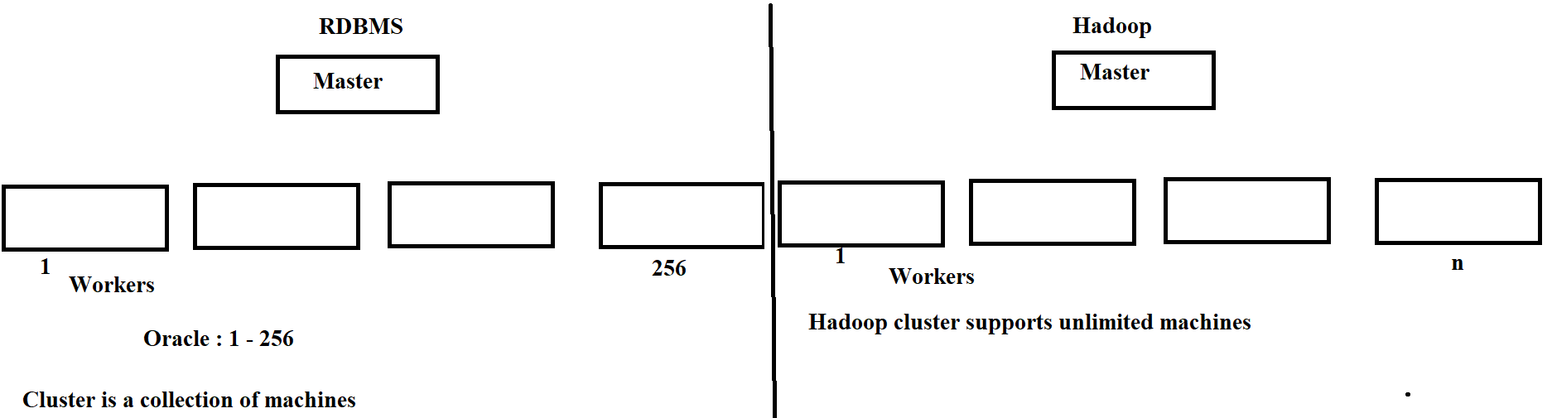

3. Distributed Data:-
- RDBMS Databases are not distributed. If we store data in RDBMS it will store in single machine.
- Hadoop is a Distributed technology. If we store any data. It will divides data into multiple blocks. Each block placed in different machine.
The default block size until Hadoop 1.x – 64MB from Hadoop 2.x It is 128MB
Lets say if we want to store 300MB data then
300MB/128MB => 3 blocks
B1 – 128MB
B2 – 128MB
B3 – 128MB
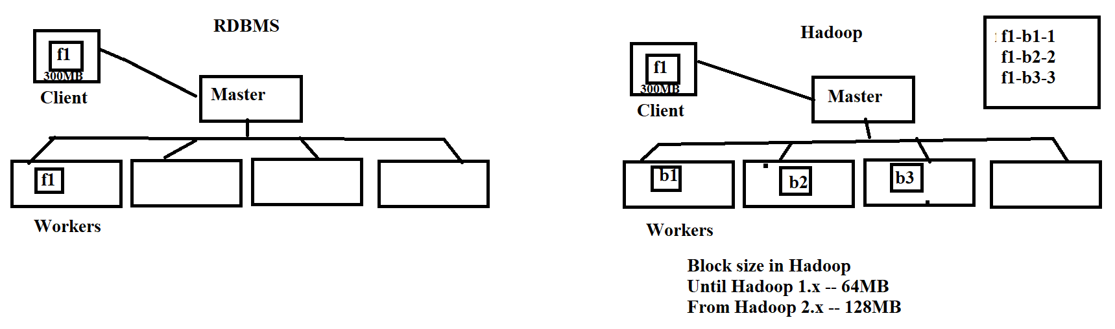
4. Parallel Processing:-
- RDBMS is not distributed so only one machine involves in processing.
- But Hadoop is distributed system. When any processing request comes many machines involves to process.
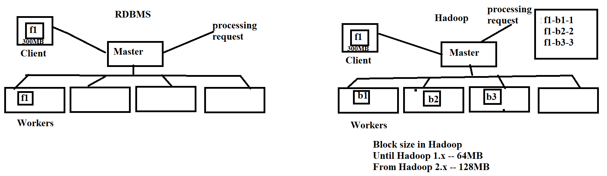
- Hadoop is a parallel processing framework.
MapReduce, Pig, Hive, Sqoop, Spark etc..

5. Automatic Failover Management:-
- Hadoop works on commodity hardware, commodity hardware failure chances are high. It resolve this issue, hadoop replicates each block with 3 copies called replication. If any machine down it will access data from other machine.
- Hadoop achieving Automatic Failover manament using Replication
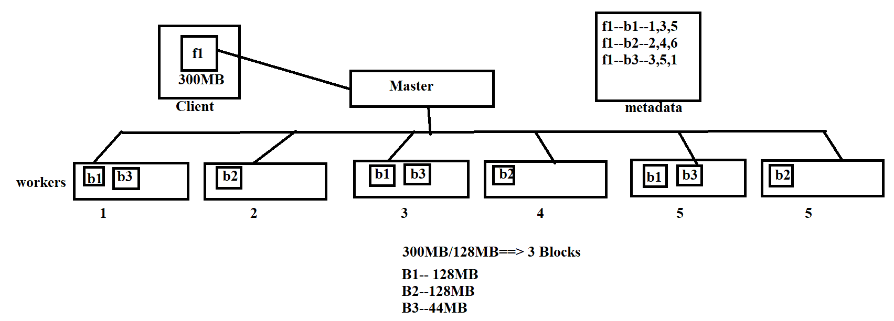
6. Data Locality Optimization:-
- In Traditional technologies data moves to processing location.
- In Hadoop programs/application instances going to create in data location, data not moves to applications locations. Application instances going to create in data location.
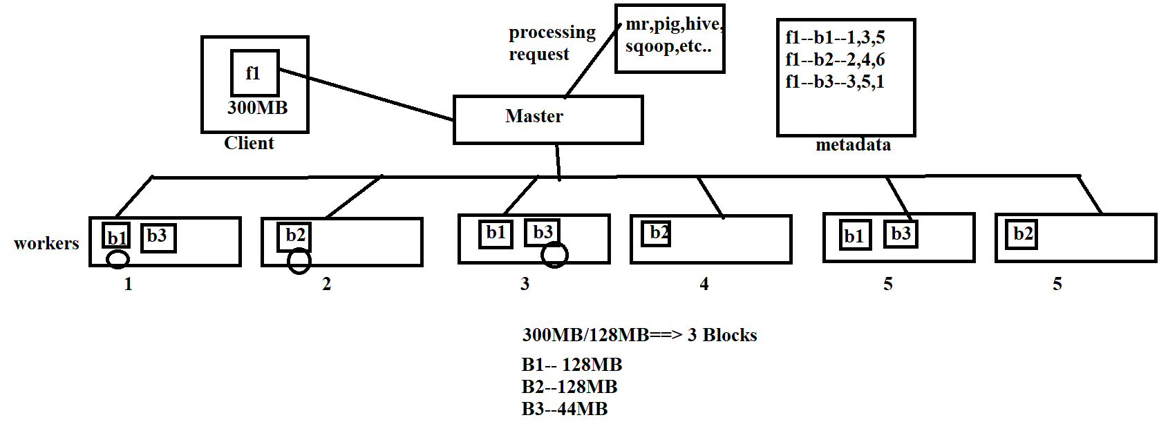
7. Heterogenous Cluster:-
- For other software’s we have take certified hardware and recommended operating system, otherwise it may fail.
- But Hadoop does not require certified hardware and specific operating system. Hadoop supports any hardware and any operating system.

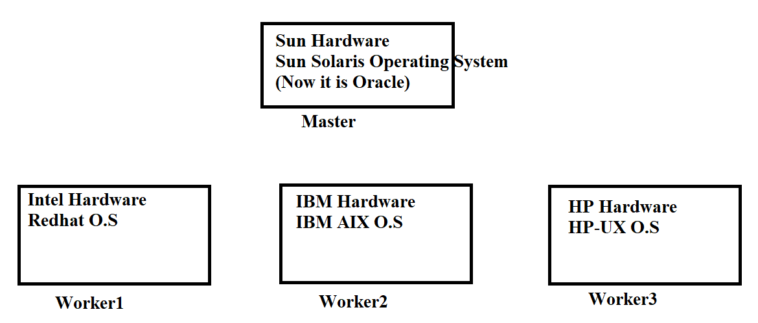

8. Scalability:-
- Hadoop supports unlimited storage. It supports unlimited machines.
- There is no limitation in hadoop cluster, we can take n no.of machines in hadoop cluster.

Hadoop Architecture
- Hadoop follows Master/Slave Architecture.
- Master machine responsible for taking requests and assigns request processing to slaves.
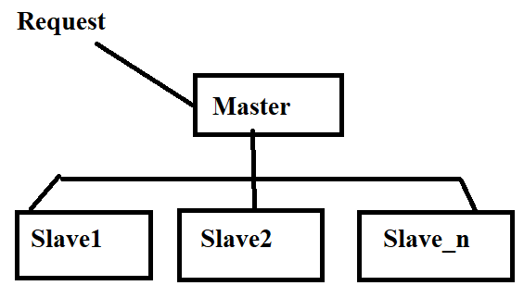
- In Hadoop Architecture, there 5 Daemons. They are:
- NameNode
- SecondaryNameNode
- DataNode
- Until Hadoop 1.x – JobTracker
From Hadoop 2.x – ResourceManager
- Until Hadoop 1.x – TaskTracker
From Hadoop 2.x – NodeManager
- What is Daemon – Is a Background process. A Daemon is a Java Class. These are predefined Java Programs.
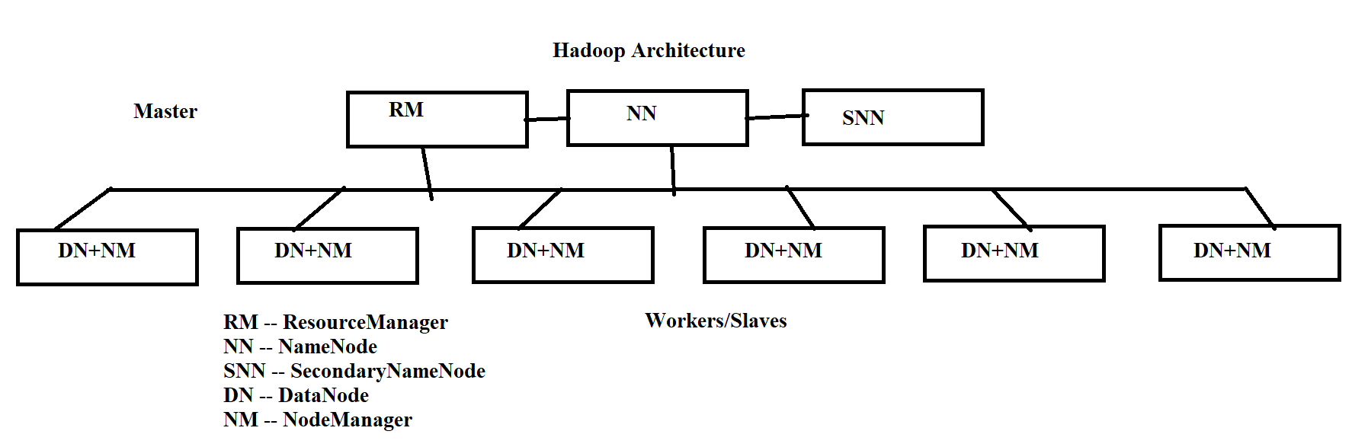
- In Hadoop Architecture
Master Daemons
NameNode
SecondaryNameNode
ResourceManager
Slave/Worker Daemons
DataNode
NodeManager
- We can take one or more Master Daemons, it is highly recommend to start Master Daemons on separate machines.
- It is highly recommended to take both worker daemons on same machine. We will take multiple Worker/Slave Machines based on our requirement.

HDFS Architecture:-
- HDFS is responsible for storage. Any Storage request taken care by HDFS Daemons.
- HDFS Daemons are:
Master Daemons
NameNode
SecondaryNameNode

Worker/Slave Daemons
DataNode
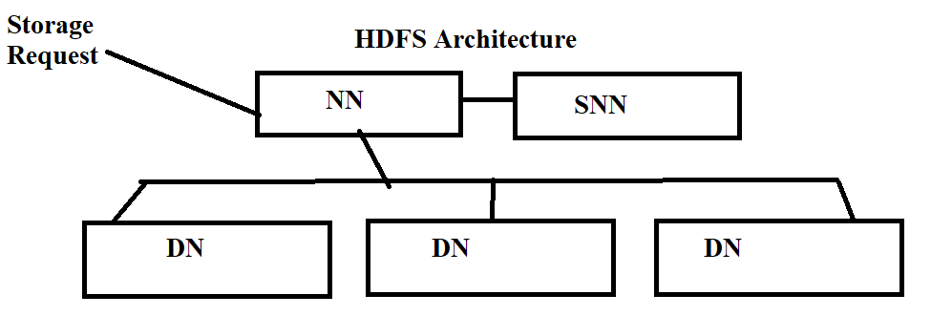
MapReduce Architecture:-
- MapReduce Architecture responsible for Processing.
- Any Processing request taken care by MapReduce Architecture.
- In MapReduce Architecture we have
Master Daemons
Until Hadoop 1.x – JobTracker
From Hadoop 2.x – ResourceManager

Worker/Slave Daemons
Until Hadoop 1.x – TaskTracker
From Hadoop 2.x – NodeManager
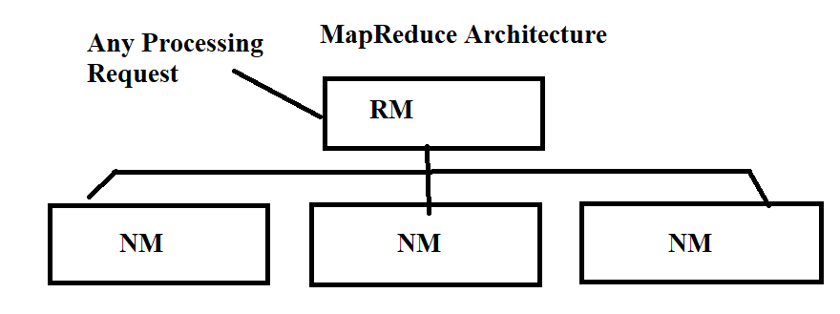
- Until Hadoop 1.x we have MapReduce 1 Architecture. In these we have MapReduce Daemons are:
JobTracker – Master
TaskTracker – Worker

- From Hadoop 2.x They introduced MapReduce 2 Architecture called YARN Architecture. . In these we have MapReduce Daemons are:
ResourceManager – Master
NodeManager – Worker
Hadoop Cluster Architecture:-
- Cluster means group of machines of collection of machines. (Machine or Node).
- Datacentre is a place or location (physical).
- Datacentre is a collection of RACK’s.
- A RACK is a Collection of machines or nodes.
- Switch – One machine communicates other machines within the same RACK or different RACK using switch.
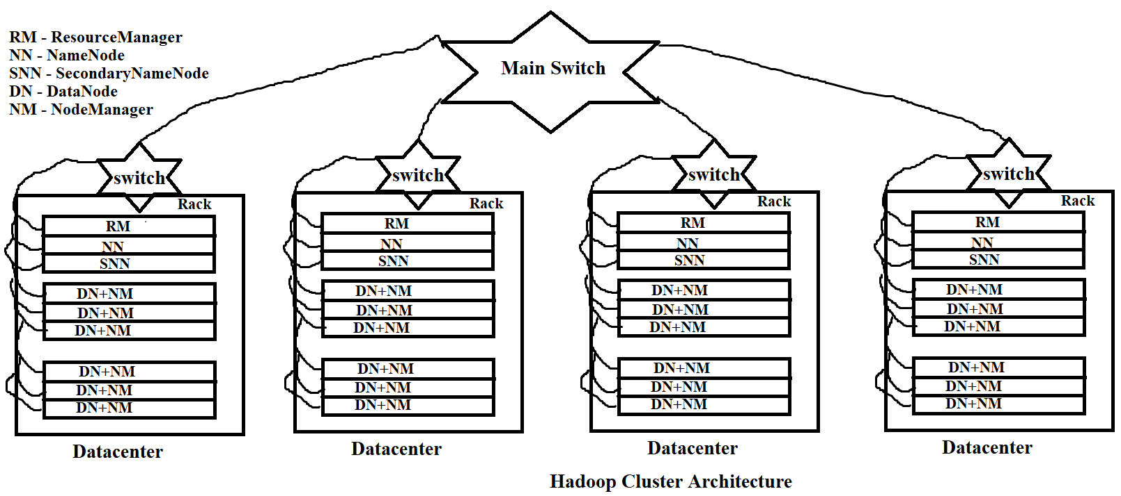

Hadoop Components
In Hadoop Architecture we have 5 important components. They are:
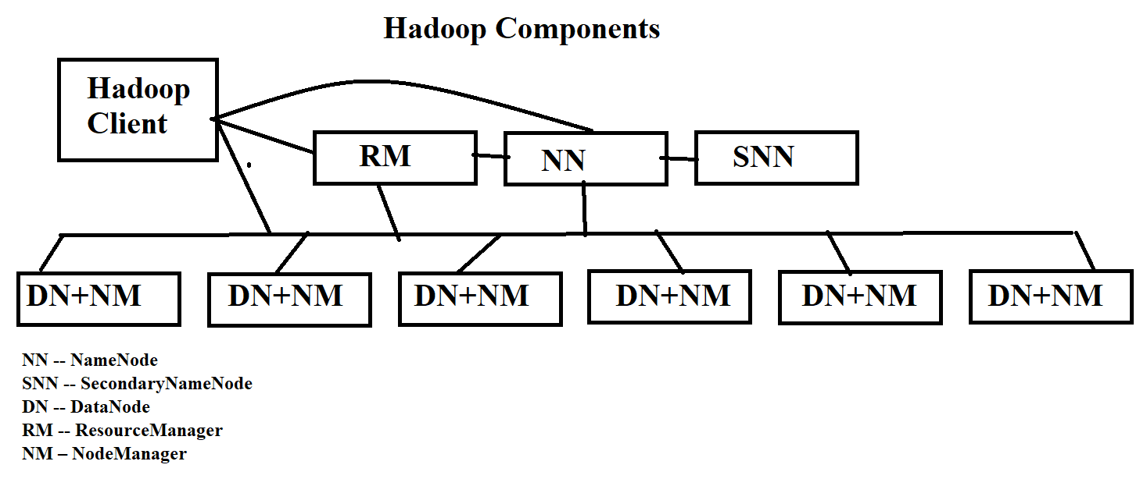
- NameNode
- SecondaryNameNode
- DataNode
- Until Hadoop 1.x – JobTracker
From Hadoop 2.x – ResourceManager
- Until Hadoop 1.x – TaskTracker
From Hadoop 2.x – NodeManager
- Hadoop Client
Hadoop Client May be HDFS, MapReduce, Pig, Hive, Sqoop, Spark, Any Java Application, Any Python Application, Any Reporting Tool, etc..

NameNode:-
- NameNode is a Master Daemon is HDFS Filesystem.
- NameNode gets storage request, when it gets request it will prepare metadata.
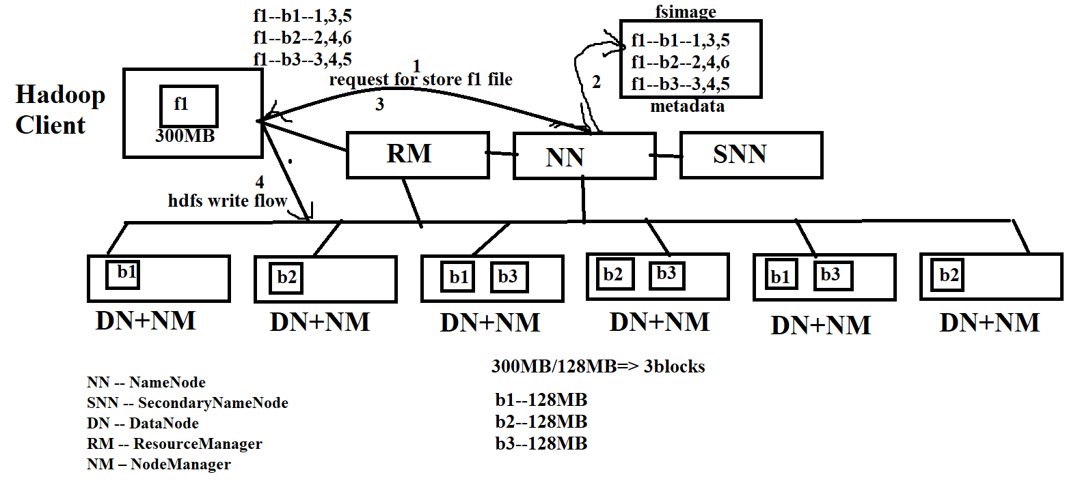
- NameNode also monitors its worker machines(DataNode’s).

What is Metadata?
- Mapping of file→to→blocks→to→DataNode’s

In Hadoop Data divides into multiple blocks.
Each block size until Hadoop 1.x – 64MB, from Hadoop 2.x –128MB

Blocks and Replication
In Hadoop, blocks are replicated, each block replicated 3times.

Block Size, Replication-Factor configured in hdfs-site.xml, if you not satisfy default values we can modify in hdfs-site.xml.

How it identifies DataNode’s to prepare metadata?
- Proximity algorithm – It contains Datacentre, Rack, Node(Machine), Bandwidth, etc..

SecondaryNameNode:-
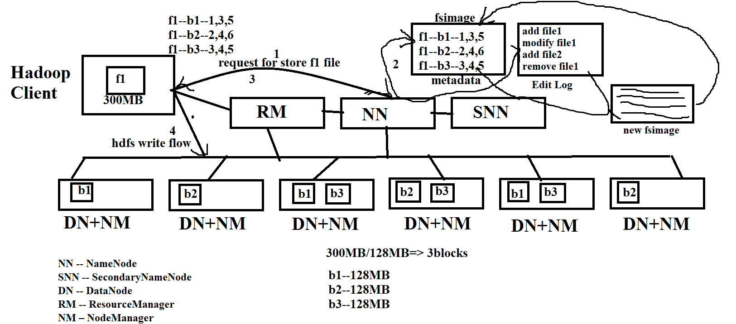
- By seeing name most of people think it is backup for NameNode but it is not.
- It is a Master Daemon. It performs checkpointing.
- Checkpointing means mean merging edit logs and FsImage is called Checkpointing.
- Edit Logs – NameNode directly not write changes into FsImage, it will write changes into Edit Logs file.
- SNN, performs checking pointing operation to merge edit log file and FsImage and creates new FsImage and updates new FsImage in NameNode’s memory.
- After new FsImage updated successfully then edit log entries are removed.
- When SNN performs Checkpointing?
dfs.namenode.checkpoint.period | 3600 | The number of seconds between two periodic checkpoints.
dfs.namenode.checkpoint.txns | 1000000 | The Secondary NameNode or CheckpointNode will create a checkpoint of the namespace every 'dfs.namenode.checkpoint.txns' transactions, regardless of whether 'dfs.namenode.checkpoint.period' has expired.
- So SNN performs checkpointing every 1hr or 1Million Transactions or entries in edit log file. This is configurable. We can configure in hdfs-site.xml.
- Without SNN, NameNode can perform but it is heavy Bordon on NameNode, restart time NameNode take more time to merge edit log and FsImage so to resolve this issue. Hadoop introduced SecondaryNameNode.
- SecondaryNameNode purpose is to perform checkpointing operation.

DataNode:-
- DataNode is a Worker/Slave Daemon.
- It is responsible for storing the data.
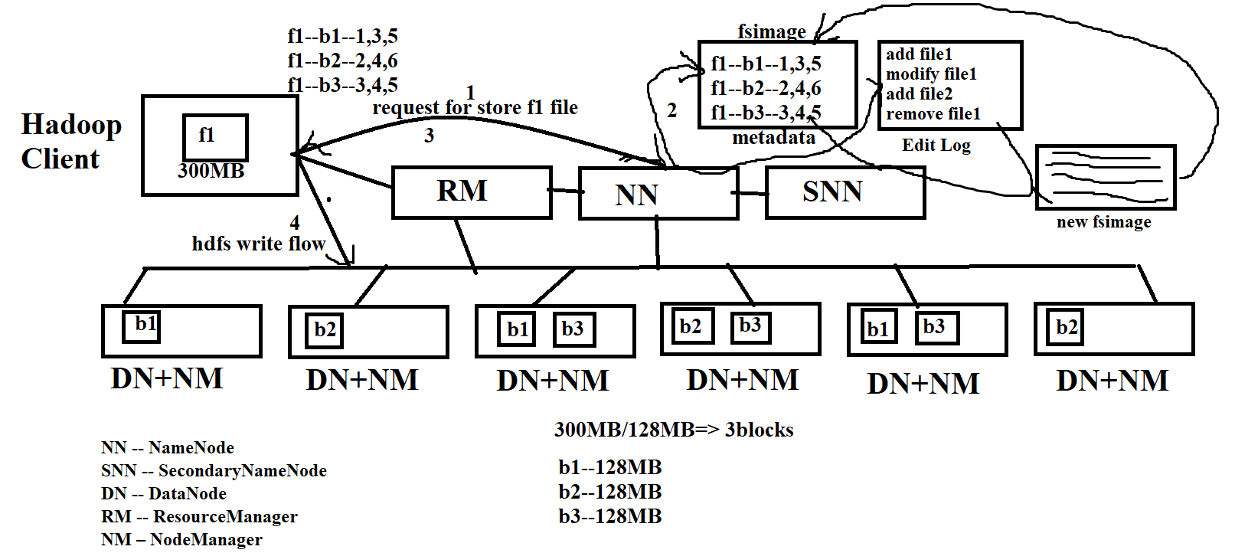
- DataNode also responsible for sending status to its master node (NameNode) called HDFS Heartbeat Signal.
- It Sends status like “ I am Active, I have so and so blocks”.
- When DataNode Sends heart beat signal?
dfs.heartbeat.interval | 3 | Determines datanode heartbeat interval in seconds.
- Every 3 seconds, Every DataNode sends heartbeat signal to NameNode. If we are not satisfy heart signal time then we can decrease or increase in hdfs-site.xml

ResourceManager:-
- Until Hadoop 1.x – JobTracker is a Master Daemon in MapReduce Architecture. (MR1)
- From Hadoop 2.x -- ResourceManager is a Master Daemon in MapReduce Architecture. (MR2) (YARN Architecture).
- YARN – Yet Another Resource Negotiator.
- When Client sends processing request to Resource Manager, RM Communicates with NN to get file information.
- NN finds file information from metadata and returns details
- After receiving file information then RM assigns tasks to NM based on sorted order of blocks and DataNode’s.
- And also it monitors weather RM running or not and RM executing tasks or not and percentage of completion.

NodeManager:-
- Until Hadoop 1.x – TaskTracker NM is a Worker Daemon in MapReduce Architecture. (MR1).
- From Hadoop 2.x NodeManager is a Worker Daemon in MapReduce Architecture (MR2) (YARN).
- It responsible to process requests assigned by ResourceManager.
- NodeManager sends heart beat signal to it master saying “I am active, I am running so and so tasks and percentage of completion of each task”.
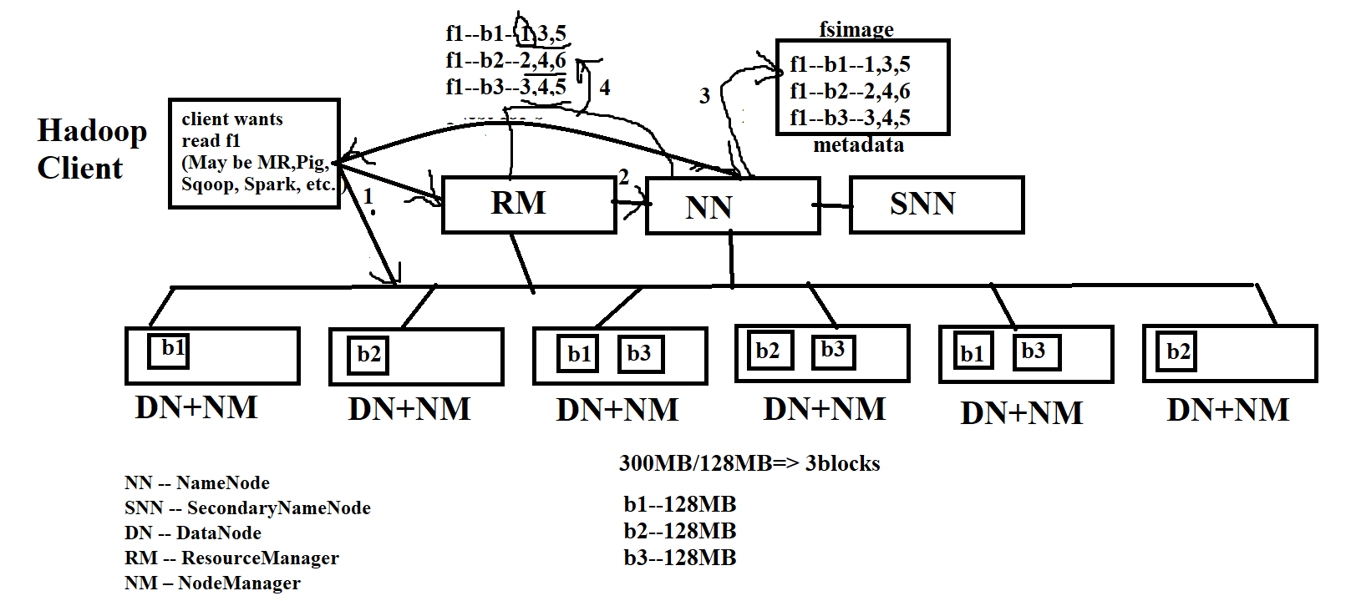
- This heart beat signal we can call “MapReduce Heartbeat Signal”.
By
Akkem Sreenivasulu – Founder of CFAMILY
eMail : info@cfamily.com
Contact: +91-9133161144
Website: www.cfamily.com
Telegram: https://t.me/cfamilyIN
YouTube: www.youtube.com/cfamily
Facebook: https://www.facebook.com/cfamilyIN/
LinkedIn : https://www.linkedin.com/in/cfamily
Instagram : https://www.instagram.com/cfamilyin/
Twitter : https://twitter.com/cfamilyIN
GitHub: https://github.com/cfamilyIN/

